Analysis Plan

  - Study aims
- Primary
    - To evaluate and compare the prognostic performance of MELD 3.0, MELD-Na, MELD, and CLIF-C ACLF scores for 90-day mortality among patients with HRS-AKI at the time of terlipressin initiation
    - To similarly assess for the secondary outcomes of 30-day mortality, response to terlipressin, and in-hospital RRT
- Secondary
    - To explore whether prognostic performance differs across subgroups relevant to clinical decision-making

  - Key analysis elements
- t₀= days_to_terli_initiation_day0
- outcome window/follow-up = 90 days from t₀
- analysis below uses days-based variables
- if needed, relevant date-based variables for outcome derivation include
    - terli_date_day0: date of terlipressin initiation
    - dc_date: date of discharge (if in-hospital death, it is also the date of death)
    - dc_death90_date: death of death (if after discharge, excluding in-hospital deaths)
    - lt_date: date of LT if happened during hospitalization
    - dc_lt_90days: date of LT if happened after discharge
    - dc_lastecounter_date: date of last pt encounter alive
    - dc_lost_to_followup_date: date of last pt encounter prior to LTFU

  - New variables
- day90_dt = days_to_terli_initiation_day0 + 90
- vitalstatus90
- dead on or before day90_dt
- alive (known to be alive beyond day90_dt)
- lost to follow-up (last confirmed alive date is before day90_dt and no death is recorded on/before day90_dt)
- time_to_transplant
    - already defined, days from terli initiation to transplant
- dc_lastencounter_days = dc_days_lastencounter + days_to_discharge - days_to_terli_initiation_day0
    - number of days from t₀ to the last documented clinical encounter after discharge
- dc_losttofollowup_days = days_to_lost_to_followup + days_to_discharge - days_to_terli_initiation_day0
    - number of days from t₀ to the date the patient was lost to follow-up
- day 0 scores
    - how to handle missing:
      - Use day 0 (t₀) lab values if present
      - If missing, use admission labs
      - If still missing, median imputation
    - day0_meld_3: MELD 3.0 computed with lab values at t₀
    - day0_meld_na: MELD-Na computed with lab values at t₀
    - day0_meld: original MELD computed with lab values at t₀
    - day0_clif_c_score: CLIF-C ACLF computed with lab values at t₀
- akin
    - already defined, day 0 AKI stage
- aclf_grade
    - already defined, day 0 ACLF grade

  - Analysis plan by tables for primary outcome
- Table 1 Baseline Demographics and Clinical Characteristics by 90-day Survival Outcome
    - Columns
      - # alive at 90 days from admission
      - # dead by 90 days from admission
      - All/entire cohort N=243
      - P values comparing alive with dead (columns 1 and 2)
    - Rows
      - age (median, IQR)
      - sex_male = 1 (n, %)
      - race (n, %)
        - race=1
        - race=2+3+4
      - hispanic=1 (n, %)
      - etoh_hepatitis=1 (n, %)
      - cirrhosis_etiology (categorial, for each n, %)
        - cirrhosis_etiology=1
        - cirrhosis_etiology=2
        - cirrhosis_etiology=3
        - cirrhosis_etiology=4
        - cirrhosis_etiology=5
        - cirrhosis_etiology=6
      - admit_reason (categorial, for each n, %)
        - admit_reason=1
        - admit_reason=2
        - admit_reason=3
        - admit_reason=4
        - admit_reason=5
        - admit_reason=6
        - admit_reason=7
      - day0_meld_3 (median, IQR)
      - day0_meld_na (median, IQR)
      - day0_meld (median, IQR)
      - day0_clif_c_score (median, IQR)
      - aclf_grade (categorical, for each n, %)
        - 0
        - 1
        - 2
        - 3
      - akin (categorical, for each n, %)
        - I
        - II
        - III
      - Complications of cirrhosis
        - refascites_previous_comp=1
        - sbp_previous_comp=1
        - phtn_bleed_previous_comp=1
        - he_previous_comp=1
        - nonsbp_previous_comp=1
      - hrs_responders (categorical, for each n, %)
        - 0
        - 1
        - 2
      - HRS_reversal_new (n, %)
      - RRT during admission (n, %)
        - rrt_2=0
        - rrt_2=1

- Table 2 Discriminative Performance of Prognostic Scores for 90-Day Mortality
    - Scores: day0_meld_3, day0_meld_na, day0_meld, day0_clif_c_score
    - Event: death within 90 days from t₀
    - Metric: time-dependent AUC at 90 days; report 95% CI
    - Compare each score’s AUC with MELD 3.0 using bootstrap resampling; report ΔAUC (difference vs MELD 3.0) and p-values
    - Supplement metric: Uno’s C statistic (iAUC); report 95% CI
      - This is to align with MELD 3.0 paper by Kim et al. in Gastro 2021. Specifically their methods report
      - “Once these models were constructed, we assessed their performance against MELD and MELDNa in the validation data set. First, discrimination by the model, namely its ability to rank patients according to the risk of death within 90 days, was evaluated using the concordance (c) statistic. Of the several methods to calculate concordance, methods by Harrell and Uno were used.”
    - Compare each score’s Uno’s C with MELD 3.0 using bootstrap resampling; report Δ (difference vs MELD 3.0) and p-values

- Figure showing time-dependent AUC curves for all the scores from t₀ to 90 days follow-up

Would look similar to below,
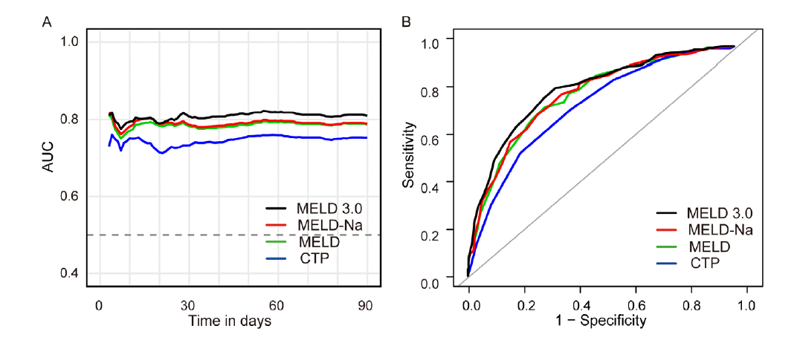

  - Table 3. Observed 90-day Cumulative Incidence of Death by Prognostic Score Categories
    - Scores: day0_meld_3, day0_meld_na, day0_meld, day0_clif_c_score
    - Event: death within 90 days from t₀
    - For each score, divide patients into bins (below)
    - Note the count (n) for each bin
        - MELD-based: <=25, 26-34, >=35
        - CLIF-C ACLF: <=40, 41-49, >=50
    - For each score, estimate observed 90-day risk of death (KM) for each bin
    - Report n per bin, observed 90-day death risk, and 95% CI
  - Bar plots showing observed 90-day death risk by score bin with error bars (for each score)

  - Table 4. Categorical Reclassification of 90-Day Decedents: MELD 3.0 vs MELD-Na
    - Scores: compare day0_meld_3 with day0_meld_na
    - Event: death within 90 days from t₀
    - Only look at patients who died within 90 days from t₀
    - Same bins as above: <=25, 26-34, >=35
    - Construct a 3 × 3 cross-tabulation:
      - Rows = MELD 3.0 tier
      - Columns = MELD-Na tier
    - Classify movements
      - Up-classified (correct): MELD 3.0 tier > MELD-Na tier
      - Down-classified (incorrect): MELD 3.0 tier < MELD-Na tier
      - Unchanged: same tier
    - Summarize
      - $n_{\text{up}}, n_{\text{down}}, n_{\text{same}}$
      - Percentages = each n / total decedents × 100 %
      - Net gain among decedents = (% up − % down)
Kind of looks like this…
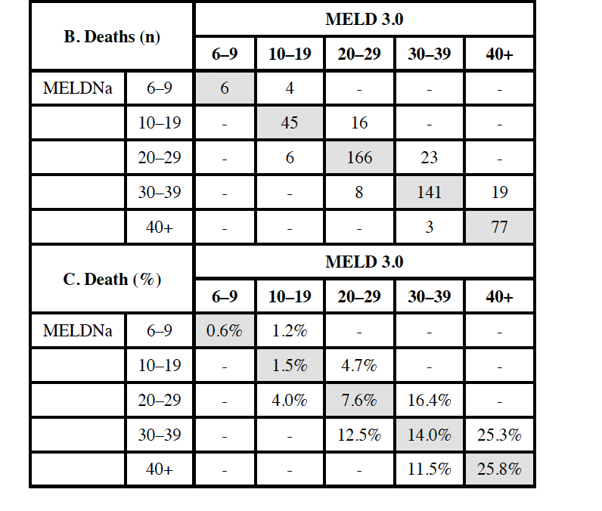

  - Analysis plan for secondary outcomes
  - Substituting 90-day mortality with 30-day mortality
    - Point is to compare 30-day data with GLOBAL-AKI cohort later on
    - Analyses for 30-day mortality will mirror those for 90-day mortality described above, except that the outcome window/follow-up will be 30 days from t₀.
    - New variables will be defined as
      - day30_dt = days_to_terli_initiation_day0 + 30
      - vitalstatus30 defined analogously to vitalstatus90, using death on or before day 30 as the event
    - All other variable definitions and analytic methods remain identical, only substituting 30-day horizon
    - Output is table 1, table 2, AUC figure, table 3, bar plot
  - Table X. Discriminative Performance of Prognostic Scores for HRS-AKI Response to Terlipressin
    - Scores: day0_meld_3, day0_meld_na, day0_meld, day0_clif_c_score
    - Follow-up: days_to_terli_initiation_day0 through days_to_discharge
    - Event: overall response to terlipressin, binary yes/no
    - Event variable would be hrs_responders_cat_2
    - Metric: ROC AUC and 95% CI
    - Compare each score with MELD 3.0 using Delong’s and generate p values
  - Figure showing ROC curves for all the scores for terlipressin response

Would look something like this


  - Table X Discriminative Performance of Prognostic Scores for RRT during Hospitalization
    - Scores: day0_meld_3, day0_meld_na, day0_meld, day0_clif_c_score
    - Follow-up: days_to_terli_initiation_day0 through days_to_discharge
    - Event: RRT during hospitalization, binary yes/no
    - Even variable would be rrt_2
    - Metric: ROC AUC and 95% CI
    - Compare each score with MELD 3.0 using Delong’s and generate p values
  - Figure showing ROC curves for all the scores for RRT during hospitalization

  - Analysis for sub-groups
  - Hold off until main analysis results. Had discussed with Kavish to use the score that performs “best” to explore subgroup
  - LT ineligible sub-cohort versus eligible
    - Ineligible: lt_eval=0, and lt_eval=1 AND lteval_listingstatus=0
    - Eligible: lt_eval=2, and lt_eval=1 AND lteval_listingstatus=1
    - Score: ***
    - Event: death within 90 days from t0
    - Metric: time dependent AUC at 90 days with 95% CI
    - Compare ineligible with eligible cohorts for the AUC and compute p-values
  - Floor versus ICU sub-cohorts at time of terli initiation
    - Floor: location_terli_day0 = 1, and location_terli_day0 = 2
    - ICU: location_terli_day0 = 3
    - Score: ***
    - Event: death within 90 days from t0
    - Metric: time-dependent AUC at 90 days with 95% CI
    - Compare floor with ICU for the AUC and compute p-values

